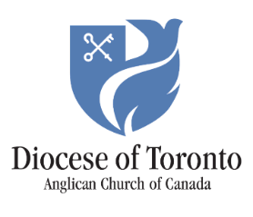
September 25, 2026
Dear Friends,
On Wednesday, I marched alongside 9,000 people, including 40 Anglicans, in solidarity at the River Run. My hands ached by the end of the day, carrying a banner that members of our Diocese had created with the slogan “Honour the Treaties.”
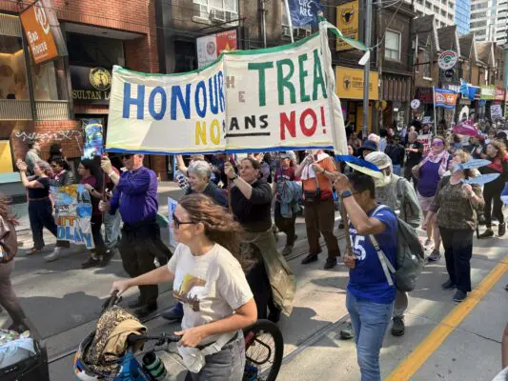Marching in the River Run. Photo by the Rev. Leigh Kern
When the rally reached Queen’s Park to lobby the premier and provincial government, I was struck by how many of the people of Grassy Narrows and Wabaseemoong First Nations, who led the march, were in wheelchairs. Speaking to the crowd of thousands, Chrissy Isaacs of Grassy Narrows shared why this was the case: “Our people are born terminally ill.” Five generations of her family have been poisoned by mercury that was dumped into their river in the 1960s by Dryden Mill, which is still in operation despite the birth defects and premature deaths of many members of Grassy Narrows and Wabaseemoong First Nations. Chrissy Isaacs thanked all of us for joining their communities, as she shared, “I won’t stop until my grandchildren’s children don’t have poison in their blood.”
The children of Grassy Narrows and Wabaseemoong First Nations matter.
This Sunday, the one closest to Sept. 30 – National Day for Truth and Reconciliation – Anglicans across our Diocese and the whole Canadian Church will wear orange shirts and lift up the truth that Every Child Matters, every child is sacred. We will grieve, pray, march in rallies, join round dances, attend ceremonies, share hard truths in our churches, learn and listen to Survivors of church-run institutions of genocide, where thousands of children tragically did not survive. I invite you to lift up the voices of Survivors in your parishes as we prayerfully commemorate Orange Shirt Day.
As a Diocese we are committed to honouring our sacred obligations and responsibilities to the Indigenous Nations impacted by the Residential School system. Through the work of the Reconciliation Land Tithe, we have committed enough finances to the Survivors Secretariat for them to hire another Indigenous researcher. We are working closely together to strengthen our relationship and walk this road of healing and justice side by side. You can learn about their work by visiting their exhibit Stolen Childhoods at the Royal Ontario Museum until Oct. 5.
The young people of Grassy Narrows and Wabaseemoong First Nations deserve childhoods of joy, living on the land, in good health and happiness. The Survivors who search for their siblings who died in Residential Schools deserve to find their loved ones and honour their graves. Indigenous children continue to face disproportionate discrimination that affects their futures and whether they will one day grow into Elders.
Our Church has much work to do to amend and repent of the harms we have participated in against Indigenous children. Please use the worship and educational resources available to your parish to deepen understanding and begin or continue the healing journey. Our Creator calls us to new and right relations, to realize the Reign of God – where Every Child Matters.
Yours in Christ,
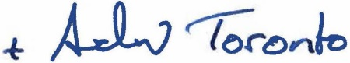
The Right Reverend Andrew Asbil
Bishop of Toronto

